APPENDIX A
PHOTOGRAPHS TAKEN DURING JIV AT 18” TEBIDABA/BRASS PIPELINE (2024/SAR/101) AT OYEREGBENE COMMUNITY, SOUTHERN IJAW L.G.A, BAYELSA STATE.
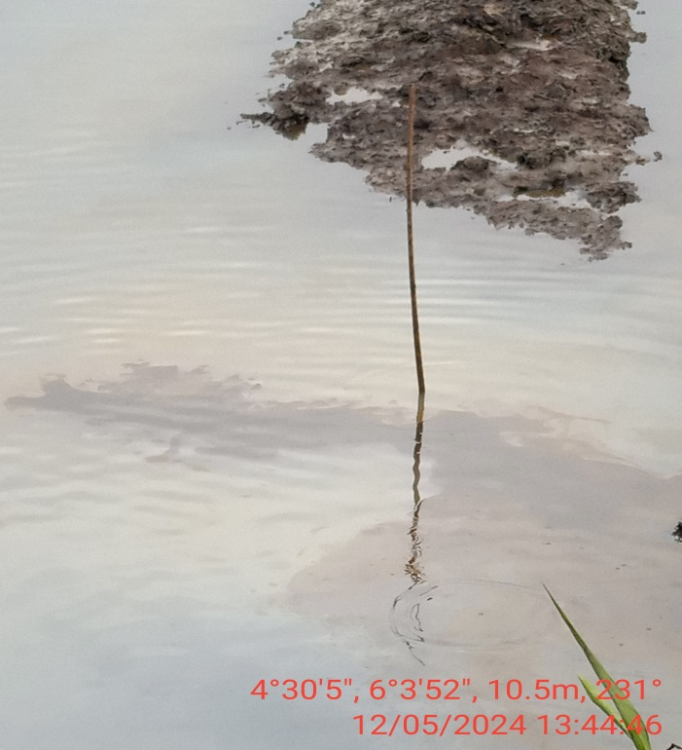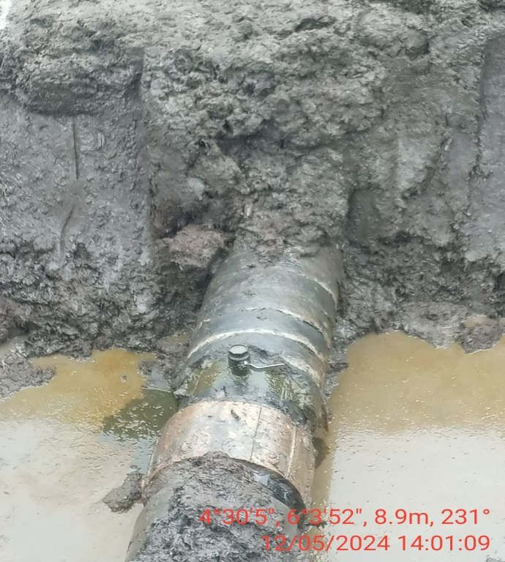
Fig. 1: The incident point before exaction. Fig. 2: 2” valve istalled at 12 o’ clock position

